Task Description #1 (AI-Based Code Completion for Loops)
Task: Use an AI code completion tool to generate a loop-based
program.
Prompt:
“Generate Python code to print all even numbers between 1 and N
using a loop.”
CODE:
N = int(input("Enter N: "))

for number in range(2, N + 1, 2):
print(number)

OUTPUT:
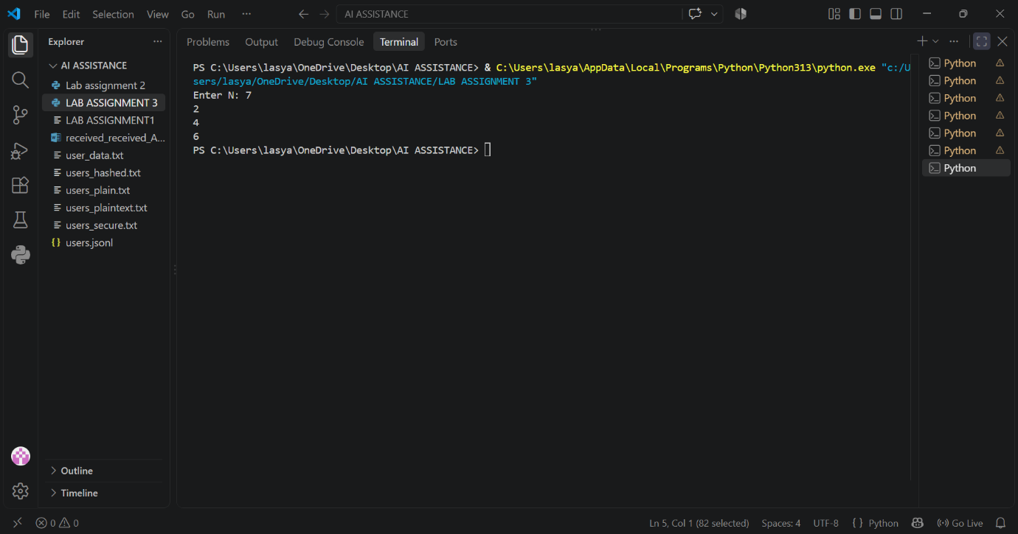
Task Description #2 (AI-Based Code Completion for Loop with
Conditionals)
Task: Use an AI code completion tool to combine loops and
conditionals.
Prompt:
“Generate Python code to count how many numbers in a list are even
and odd.”
CODE:
def count_even_and_odd(numbers):
even_count = sum(number % 2 == 0 for number in numbers)
odd_count = sum(number % 2 != 0 for number in numbers)
return even_count, odd_count

numbers = [1, 2, 3, 4, 5, 6]
even_count, odd_count = count_even_and_odd(numbers)

print("Even numbers:", even_count)
print("Odd numbers:", odd_count)

OUTPUT:
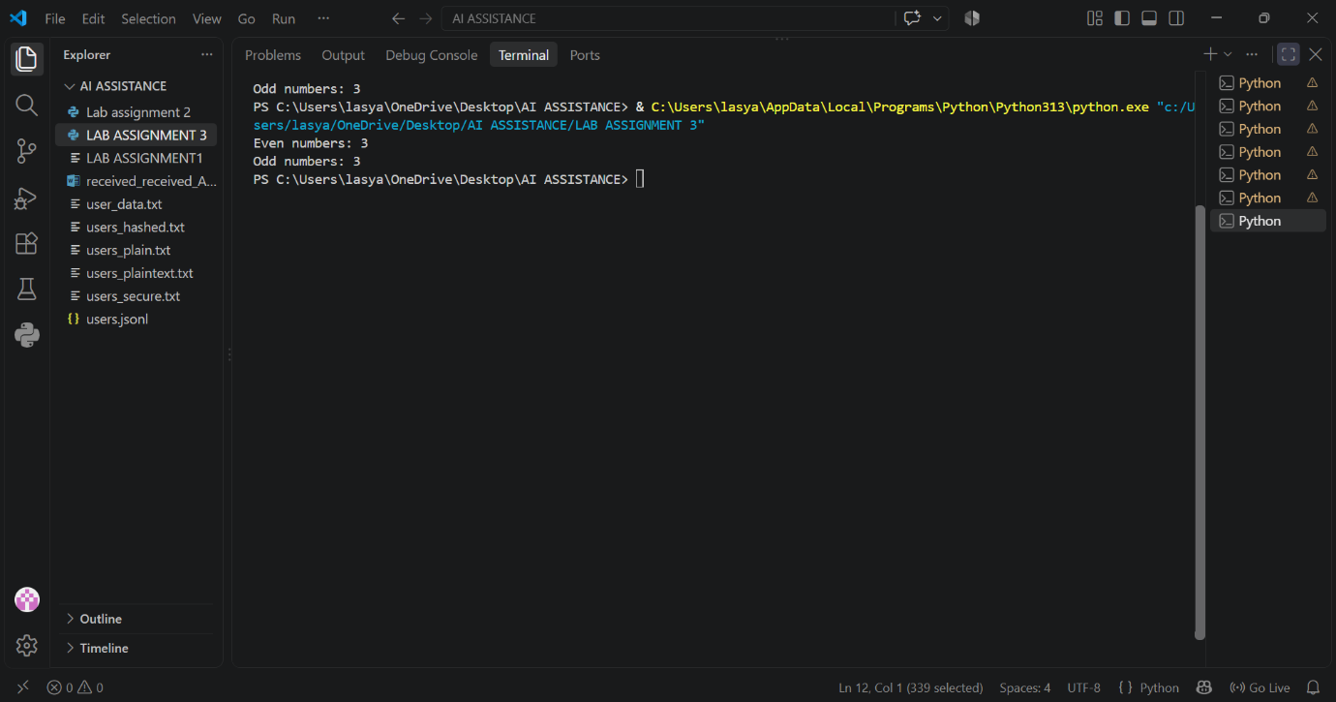
Task Description #3 (AI-Based Code Completion for Class
Attributes Validation)
Task: Use an AI tool to complete a Python class that validates user
input.
Prompt:
“Generate a Python class User that validates age and email using
conditional statements.”
CODE:
class User:
def __init__(self, age, email):
self.age = age
self.email = email

def validate(self):
# Age validation
if self.age < 18:
print("Invalid Age: User must be 18 or older.")
age_valid = False
else:
print("Valid Age")
age_valid = True

# Email validation
if "@" in self.email and "." in self.email:
print("Valid Email")
email_valid = True
else:
print("Invalid Email")
email_valid = False

# Final validation
if age_valid and email_valid:
print("User details are valid.")
else:
print("User details are invalid.")

# Test Case 1: Valid input
print("Test Case 1")
user1 = User(20, "student@gmail.com")
user1.validate()

# Test Case 2: Invalid age
print("\nTest Case 2")
user2 = User(16, "student@gmail.com")
user2.validate()

# Test Case 3: Invalid email
print("\nTest Case 3")
user3 = User(21, "studentgmail.com")
user3.validate()

# Test Case 4: Both invalid
print("\nTest Case 4")
user4 = User(15, "studentgmail")
user4.validate()
OUTPUT:
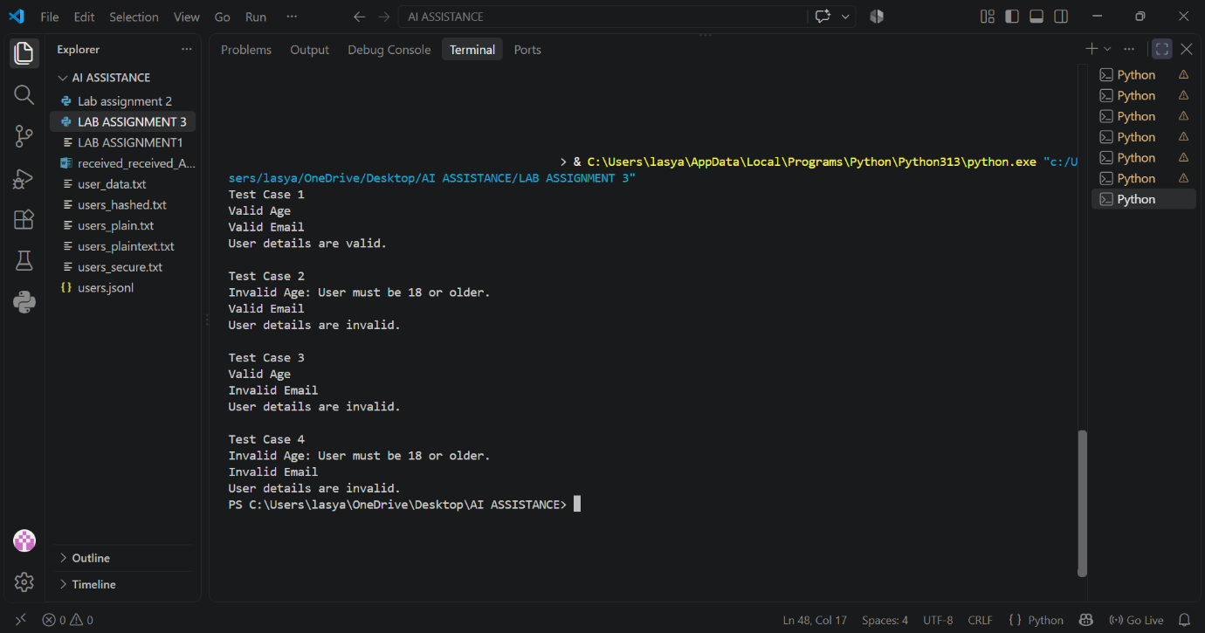
Task Description #4 (AI-Based Code Completion for Classes)
Task: Use an AI code completion tool to generate a Python class for
managing student details.
Prompt:
“Generate a Python class Student with attributes (name, roll number,
marks) and methods to calculate total and average marks.”
CODE:
class Student:
def __init__(self, name, roll_number, marks):
self.name = name
self.roll_number = roll_number
self.marks = marks

def calculate_total(self):
return sum(self.marks)

def calculate_average(self):
return self.calculate_total() / len(self.marks) if self.marks else 0

OUTPUT:
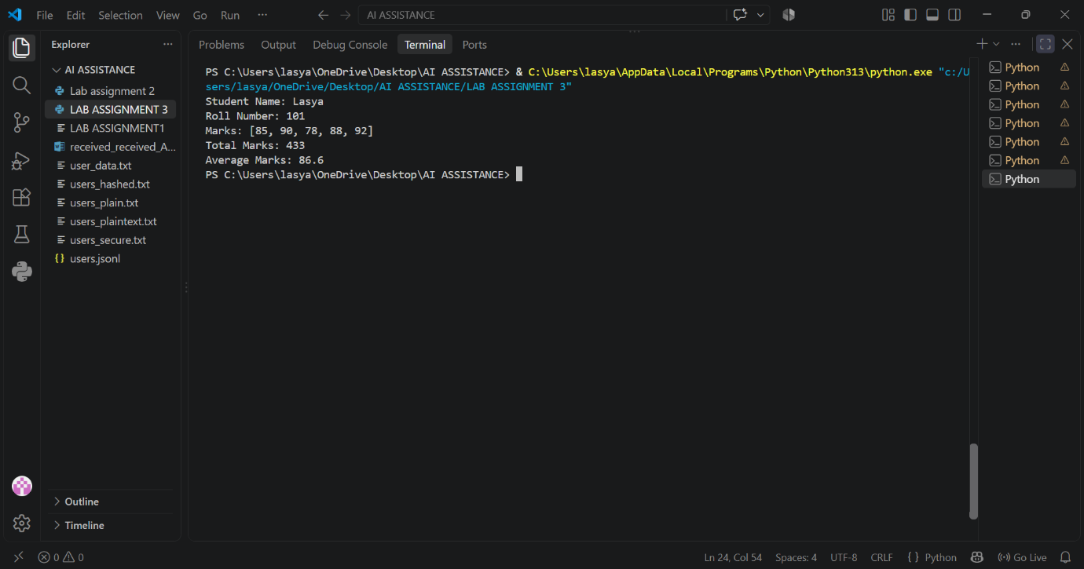
Task Description 5 (AI-Assisted Code Completion Review)
Task: Use an AI tool to generate a complete Python program using
classes, loops, and conditionals together.
Prompt:
“Generate a Python program for a simple bank account system using
class, loops, and conditional statements.”
CODE:
class BankAccount:
def __init__(self, account_holder, balance=0.0):
self.account_holder = account_holder
self.balance = balance

def deposit(self, amount):
if amount > 0:
self.balance += amount
print(f"Deposited ${amount:.2f}.")
else:
print("Deposit amount must be positive.")

def withdraw(self, amount):
if amount <= 0:
print("Withdrawal amount must be positive.")
elif amount > self.balance:
print("Insufficient funds.")
else:
self.balance -= amount
print(f"Withdrew ${amount:.2f}.")

def display_balance(self):
print(f"Current balance: ${self.balance:.2f}")

def main():
name = input("Enter account holder name: ")
account = BankAccount(name)

while True:
print("\n--- Bank Account Menu ---")
print("1. Deposit")
print("2. Withdraw")
print("3. Check balance")
print("4. Exit")

choice = input("Choose an option: ")

if choice == "1":
try:
account.deposit(float(input("Enter deposit amount: $")))
except ValueError:
print("Please enter a valid number.")
elif choice == "2":
try:
account.withdraw(float(input("Enter withdrawal amount: $")))
except ValueError:
print("Please enter a valid number.")
elif choice == "3":
account.display_balance()
elif choice == "4":
print("Thank you for using the bank system.")
break
else:
print("Invalid choice. Please try again.")

if __name__ == "__main__":
main()

OUTPUT:
